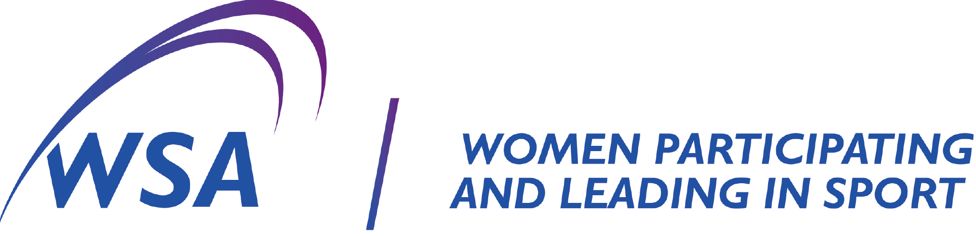

**NOMINATION FOR BOARD DIRECTOR 2024**

Nominations are called for the position of director (that is a member of the management committee) of Women Sport Australia Inc. (in accordance with the Constitution) for election at the Annual General Meeting on Wednesday 2nd October, 2024 commencing at 7.00pm, Australian Daylight Savings Time.

Three positions are available for election. If more than the required nominations are received, a ballot will be conducted.

Please note, only current WSA members will be permitted to nominate or second a nomination for a position and vote at the AGM.

Nominations must be accompanied by a brief (no more than one page) biography of the skills and experience of the candidate.

Nominations are to be received by the Nominations Committee Chair, at [iainroy@womensportaustralia.com.au](mailto:iainroy@womensportaustralia.com.au) by 5.00pm, Wednesday 14th August 2024.

For further information, email the Chair as above.

# NOMINATION

We ……………………………..……………… (proposer) and ………….….………………………… (seconder)

hereby nominate ……………………………………………..for the position of …………………………..……….

____________________________ ________________

Signature of Proposer Date

____________________________ ________________

Signature of Seconder Date

**I hereby consent to the above nomination**.

________________________ ________________

Signature of Nominee Date